MEETING SCHEDULE

Sunday
12:00 – 1:00 pm: “Voices of Hope” (Open)
Club 1 – 12, 1955 Scenic Hwy, Baton Rouge, LA

Tuesday
8:00 – 9:00 pm: “We Care Too” (Open)
O’Brien House, 1201 Laurel Street, Baton Rouge, LA

Saturday
8:00 – 9:00 pm: “We Care Too” (Open)
O’Brien House, 1201 Laurel Street, Baton Rouge, LA

PHONE NUMBERS
___________________________________________________________________________________
___________________________________________________________________________________
___________________________________________________________________________________
___________________________________________________________________________________
___________________________________________________________________________________

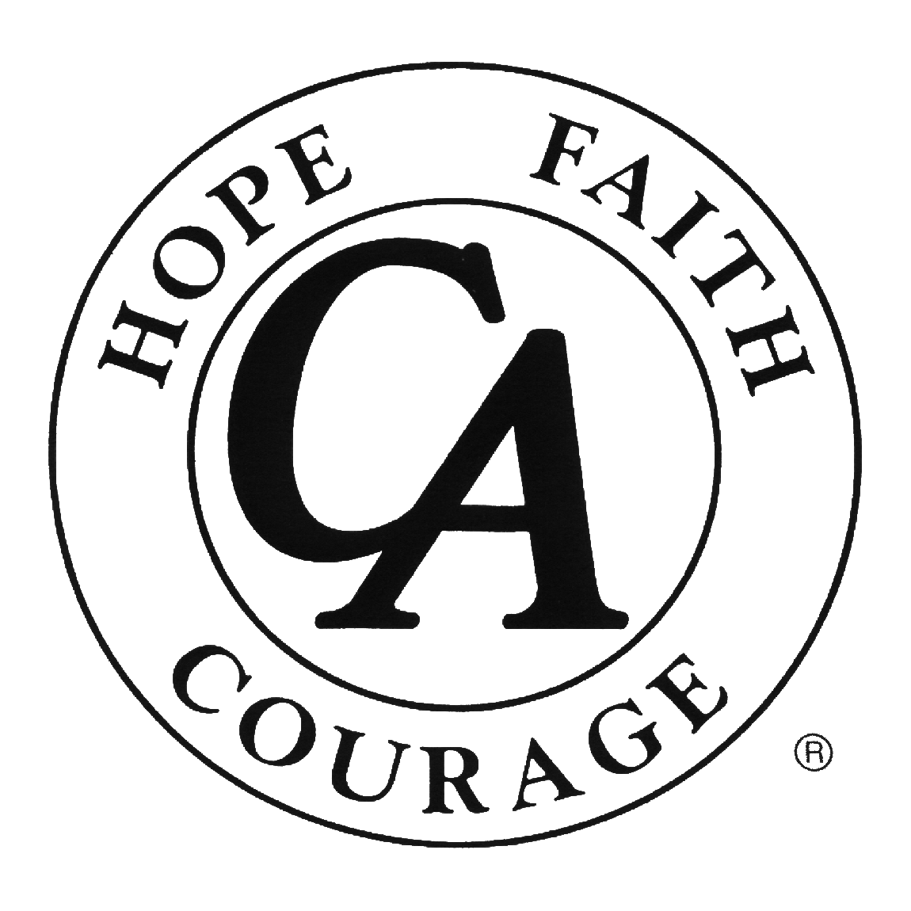
Cocaine Anonymous
MEETING DIRECTORY

BRDLA
Baton Rouge, LA District
Of Cocaine Anonymous

www.ca.org
“We’re here and we’re free.”

