MEETINGS
Sunday
8:00pm: “Hope, Faith, and Courage” (Open)
Grace House- 1160 Camp St, New Orleans (NO), LA:
*Meet in Jay Weil room around corner on Calliope St.
Monday
7:30pm: “The Misfits” (Open)
Gateway Recovery Syst. 4103 Lac Couture Dr, Harvey, LA
*Meet in 2rd door on the right after entering front gates*
7:30pm: “The Last Straw” (Closed/H & I)
Odyssey House - 1125 N. Tonti St. NO, LA
Tuesday
5:30pm: “Right Path” (Open)
Responsibility House- 5001 Westbank Expwy, Marrero, LA
Wednesday
7:30pm: “Westside Story” (Open)
Ochsner© Med. Ctr. Cafeteria 2500 Belle Chase Hwy, Gretna, LA
8:00pm: “We Think Not” (Open)
Boulevard Club 124 N. Jeff Davis Hwy, NO, LA *back room*
Thursday
5:30pm: “Right Path” (Open)
Responsibility House 5001 Westbank Expwy, Marrero, LA
Friday
8:00pm: “Bridge to Freedom” (Open)
Grace House- 1160 Camp St, New Orleans, LA:
*Meet in Jay Weil room around corner on Calliope St.
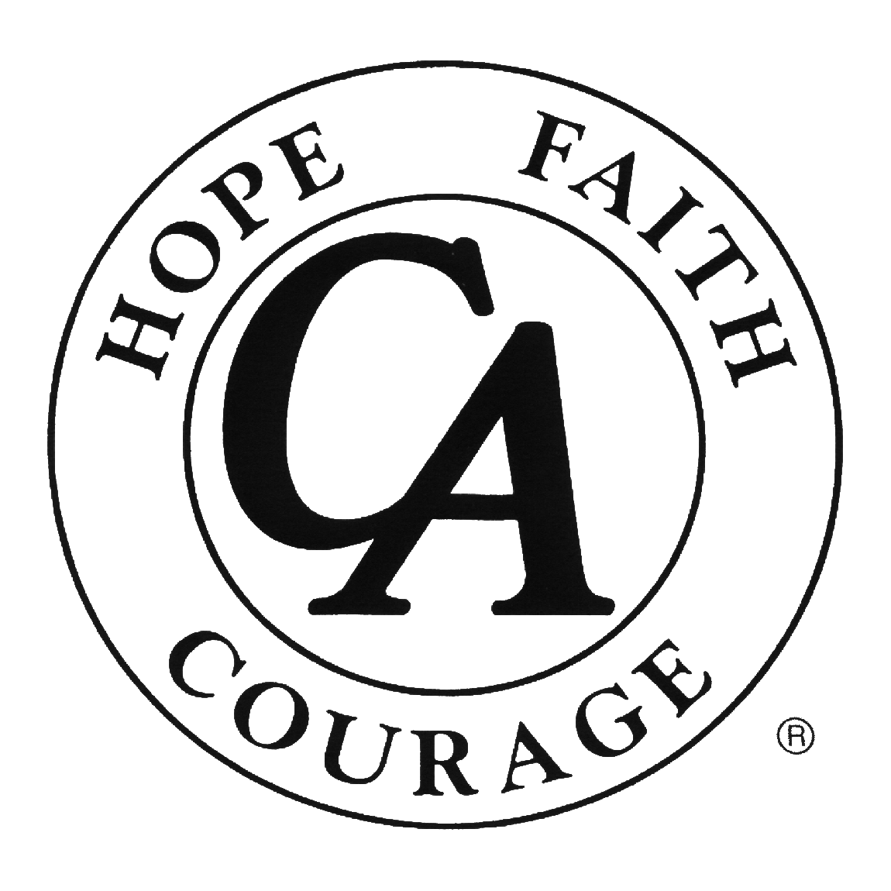
Cocaine Anonymous
MEETING DIRECTORY
CANOLA
New Orleans, LA District
Of Cocaine Anonymous

www.ca.org
“We’re here and we’re free.”

PHONE NUMBERS
___________________________________________________________________________________
___________________________________________________________________________________
___________________________________________________________________________________
___________________________________________________________________________________

